**Project Proposal**

Qitian LI Xiaoyi Wang

**Introduction**

Our bot aims to initiate a personalized interaction by sending a private message to users interested in specific tags, inquiring if they would like to receive daily updates on the hottest posts under these tags for the next ten days. Users expressing affirmative interest will be subscribed to a custom push notification service, receiving a daily digest of the most popular content. Conversely, those who decline or express disinterest will not receive further communications, respecting their preference and privacy.

**MVP(Minimum Viable Product)**

We plan to use a bot to identify the top 10 hottest posts within a specific subreddit and directly message those users. The message will inquire if they are interested in subscribing to daily updates related to that subreddit. If they respond affirmatively, we will proceed to send them a daily digest for a duration of either one week or three days, depending on their preference. Should they decline, no further messages will be sent.We will also analyze this post through the sentiment analysis function. If the score is too low, we will consider pushing other posts.

**Function in MVP**

Implement an algorithmically generated subscription mechanism designed for more efficient and customized browsing of posts.

**Objective:** Develop a bot that identifies and shares the top 10 trending posts from specified Reddit tags or subreddits with users.

**Functionality:** The bot will send a private message to users interacting with these tags, asking if they wish to receive a daily digest of the top posts over the next ten days. Users who consent will be subscribed to the service, while those who decline will not receive further messages.

**Trending Post Identification:** The bot will analyze specified subreddits daily to identify the top 10 trending posts based on upvotes and engagement metrics.

**User Messaging:** Upon identifying these posts, the bot will send a private message (PM) to the authors and commenters of these trending posts. The message will inquire if they are interested in subscribing to daily updates related to that subreddit.

**Daily Digest Delivery:** Subscribed users will receive a PM with a daily digest of the top posts from their selected subreddit(s) according to the duration of their subscription.

**Sentiment Analysis:** Posts will undergo sentiment analysis to ensure that the content pushed to users maintains a positive or neutral tone. Posts with significantly negative sentiment scores will be excluded from the digest.

**Dream Version:**

*Beyond the MVP, the dream version includes*

1. User customization options for digest frequency and content types.
2. Design a "content discovery" feature that periodically suggests new subsections or tags that may be of interest to users, who can subscribe or decline directly by replying to a private message.
3. Users can reply to the PM to opt in or out. If they opt-in, they can specify whether they prefer updates for one week or three days.
4. Develop a simple rating system that allows users to rate incoming content through private message replies

**Implementation Approach:**

Data Collection: Utilize Reddit's API to fetch top trending posts based on specific tags.

User Interaction: Implement Reddit's messaging API to communicate with users, asking for their preferences and consent.It mainly asks users whether they are willing to subscribe to our automatic replies, and captures the keywords of yes or no.

Content Delivery: Develop a scheduling system to automate the process of sending daily digests to subscribed users.

Privacy and Consent: Ensure all interactions comply with Reddit's policies and respect user privacy.

Make sure your content delivery system can handle users in different time zones, delivering content according to their local time.

**Code Function introduction and Loop example**

Get the top 10 hot posts from the "science" subreddit using a for loop.

Implement a time delay with time.sleep(24 * 3600) to wait for 24 hours before checking for responses.

def trending(subreddit, limit=10)

def send_private_message(username, message)

def process_user_reply(username):

def generate_content_digest(posts):

'Yes' Responses: If the response is 'yes', add the user to a set of subscribed users. Check if the user is already subscribed; if not, subscribe them to the subreddit.

'No' Responses: If the response is 'no' and the user is subscribed, unsubscribe them from the subreddit.

Retrieve New Top Posts: Fetch the new top 10 hot posts from the subreddit.

Sentiment Analysis: Use SentimentIntensityAnalyzer to analyze the sentiment of each post's title within a for loop.

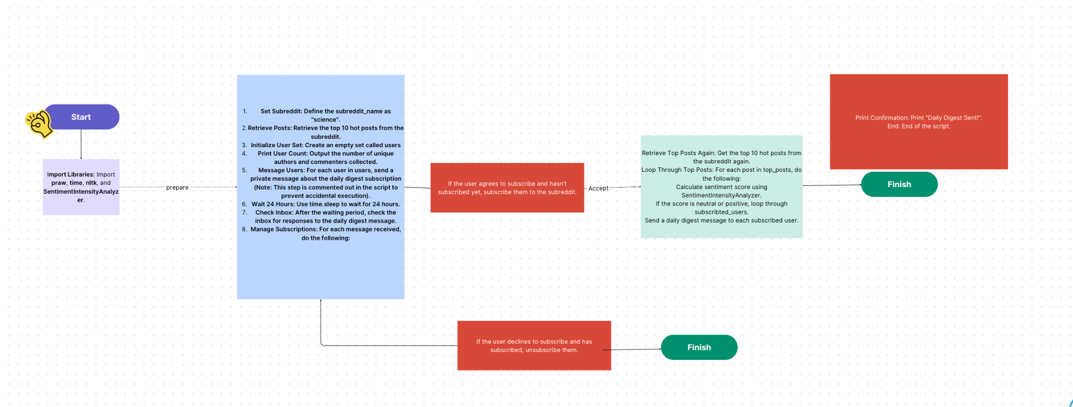

**Beta Vision**

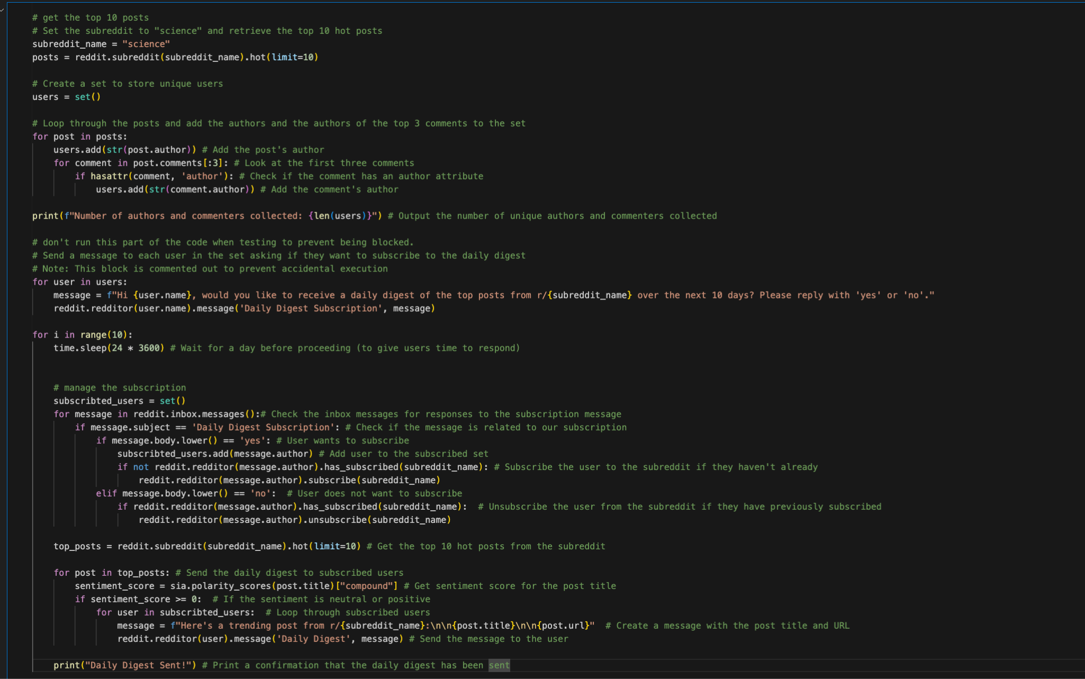

**Three ethical questions**

Q1

What steps can we take to prevent bots from perpetuating bias in content moderation?

Q2

This question explores the ethical implications of automated systems that might narrow the scope of information provided to users?

Q3

How to prevent trolling and does it affect the functionality of the bots?

**Two ethics frameworks**